13th March 2017

GP surgery rated ‘outstanding’ by health watchdog inspectors
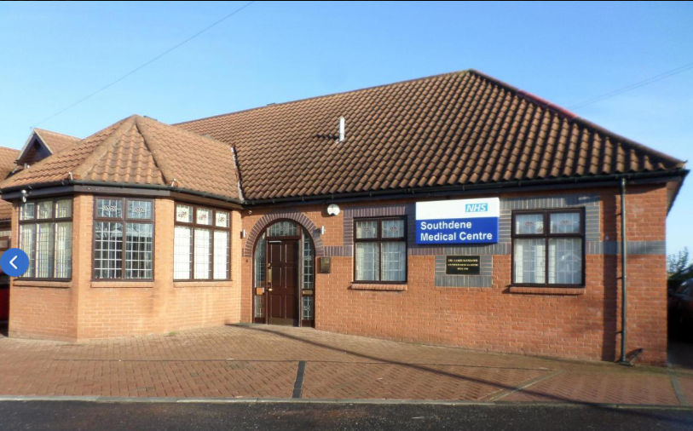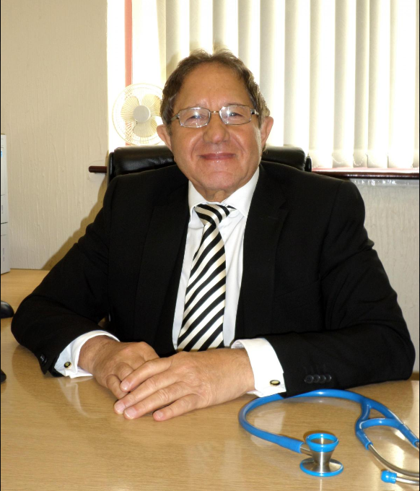
Staff at a GP surgery are celebrating after it was rated outstanding by a health watchdog.

Following an inspection by the Care Quality Commission (CQC) in November, Southdene Medical Centre in Shotton Colliery has been graded as outstanding for safety, effectiveness and how well-led the facility is while it was also rated good for caring and responsiveness.
Inspectors said that they found the Front Street practice to use “innovative and proactive methods” to improve patient outcomes, while it also had a high rate of clinical audit for its size.
The report added that patients said they were treated with compassion, dignity and respect and they were involved in their care and decisions about their treatment.
Senior partner at the practice Dr Samir Mansour said: “We were delighted to receive the news that Southdene Medical Centre has achieved an overall outstanding result following the CQC inspection.
“Our aim at Southdene is to provide the best possible care to our patients and it has boosted staff morale to receive the recognition for our efforts.
“Our hope is that we will continue to provide an excellent service to the people of the Easington area.
“We hope to continue to provide innovative education to our patients while fulfilling all of their healthcare needs.”
CQC’s deputy chief inspector of general practice in the north, Alison Holbourn said: “This is an impressive service that has a clear vision which had quality and safety as its top priority. “Inspectors could see that there were strong arrangements in place to safeguard adults and children from abuse.
“For example, they regularly generated a report of children who missed appointments and of children who had injured themselves and attended the A&E department or out of hour’s service.
“These would be reviewed to identify trends and warnings signs which led to further action. “The practice had been recognised locally over the years as having a good track record for the prescribing of medication.
“They were the second lowest prescribers of antibiotics in the locality out of 39 practices. “The practice invested in its staff.
“There was continuing development of staff skills, staff received appropriate training for their roles and appraisals and supervisions were carried out for all staff.
“The nurse practitioner had been supported to train for this role.”
Ms Holbourn added: “The practice placed a strong emphasis on patient education.
“In addition to the usual education provided to patients during regular appointments they arranged an education programme with diabetic patients with a local renal consultant in May 2016.
“The practice monitored the personal diabetes control of the patients who attended this session and found that 38% of patients who attended (eight) lost weight and improved the control of their diabetes.
“This was just one of the many reasons why we have found this practice to be outstanding and I congratulate everyone.”
Read more at: http://www.sunderlandecho.com/news/health/gp-surgery-rated-outstanding-by-health-watchdog-inspectors-1-8432848

